 | Industry: Pharmaceuticals Manufacturing Industry  Buyer Persona: Finance Director, Head of Finance, Controller, Accountant  Product: Ambient's Enterprise Software Platform for Financial Management  Author: Ivan Damnjanovic  Publish Date: May 31, 2023
Transforming Financial Management
Unlocking Financial Management Excellence in the Pharmaceuticals Manufacturing Sector with Ambient

Introduction
Welcome to our case study on how Ambient Systems can revolutionize pharmaceutical manufacturing. In this study, we will explore the challenges faced by the pharmaceutical industry and how our advanced software platform can transform manufacturing processes, enhance efficiency, and ensure compliance with regulatory requirements.

The Story of Pharmaceutical Manufacturing  The pharmaceutical manufacturing industry plays a critical role in producing life-saving medications and treatments. However, it faces challenges such as complex supply chain management, regulatory compliance, quality control, and resource allocation. In order to meet the increasing demand for pharmaceutical products, companies in the industry are actively seeking innovative solutions to streamline operations and optimize manufacturing processes. |  | 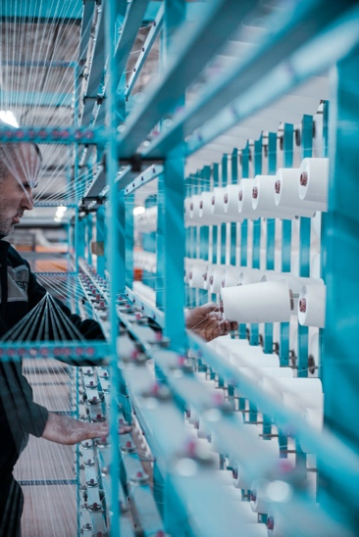
The Challenge of Fragmented Financial Management Processes Before Ambient Systems |  | Pharmaceutical manufacturers face the challenge of maintaining efficient and compliant manufacturing processes while meeting the growing demands of the market. With complex supply chains, stringent regulations, and the need for quality control, manufacturers are seeking solutions to improve operational efficiency, reduce costs, and ensure product quality and safety.

Why Ambient Systems is the Ideal Solution | Ambient Systems offers a comprehensive solution to address the challenges in pharmaceutical manufacturing. By implementing our advanced software platform, pharmaceutical manufacturers can unlock a range of benefits that will revolutionize their manufacturing operations.
How Ambient Systems Responds | Ambient Systems provides an integrated software platform designed specifically for pharmaceutical manufacturing. Our platform enables seamless supply chain management, automates regulatory compliance processes, facilitates quality control, and optimizes resource allocation. Through real-time monitoring and analytics, manufacturers gain visibility into their operations, enabling data-driven decision-making and continuous improvement.

The Results
After implementing Ambient Systems' software platform, pharmaceutical manufacturers can experience significant improvements in their operations. Key results include:
- Streamlined supply chain management, leading to improved inventory management, reduced stockouts, and enhanced production planning.
- Enhanced regulatory compliance, ensuring adherence to GMP and other regulatory requirements, reducing the risk of penalties and product recalls.
- Improved quality control, enabling early detection of issues, reducing product defects, and enhancing overall product quality.
- Optimized resource allocation, leading to improved production efficiency, reduced waste, and increased productivity.
- Real-time monitoring and analytics, providing actionable insights for proactive decision-making, process optimization, and continuous improvement.

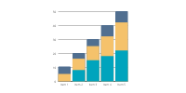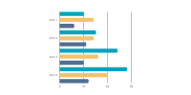

Call-to-Action
If you are a pharmaceutical manufacturer seeking to revolutionize your manufacturing operations, contact our sales team today. Discover how Ambient Systems can transform your operations, improve efficiency, ensure compliance, and drive success in the pharmaceutical manufacturing industry.

